Computational thinking of Retail Sales Order and Billing System Analyzer

- Decomposition

Product Management Module
Product Identification
Product Information
Product Price
Product Search

Customer Management Module
Customer Identification
Customer Search
Customer Purchase Tracking
Customer Location Analysis
Order Management Module
Product Selection
Quantity Management
Order Creation
Order Confirmation
Order Tracking
Billing Management Module
Bill Calculation
Invoice Generation
Payment Processing
Transaction Recording
Sales module
Daily Sales Analysis
Monthly Sales Analysis
Revenue Analysis
Top Selling Product
Countrywise Sales Analysis

- Pattern Recognition
Identify similarities and repeated processes

Common Product

Unique StockCode
Appear in multiple transactions
predefined unit price

Common billing operation
Retrieve product price
Calculate total amount
Generate invoice
Process payment
Record transaction

Common Sells reporting Activity
Calculating total revenue
Identify top-selling product
Compare sales across countries
Common Order Operation
Choose product
Scan product
Put quantity
Create order
Confirm order

Common Sales Process
Every transaction follows a similar workflow:
Customer Selects Product
↓
Order Created
↓
Bill Calculated
↓
Invoice Generated
↓
Transaction Recorded
↓
Sales Report Updated

- Abstraction
Product
StockCode
Description
UnitPrice
Customer
CustomerID
Country
Order
InvoiceNo
Quantity
InvoiceDate
Billing
UnitPrice
Quantity
InvoiceNo
Sales Reporting
Revenue
Product sales
countrywise sales

Unnessesaey info
Customer’s Personal Inrerest
Product packing color

- Algorithm Design
Algorithm
Start
- Load the retail sales dataset.
- Read the transaction details:
  - InvoiceNo
  - StockCode
  - Description
  - Quantity
  - UnitPrice
  - CustomerID
  - Country
- Calculate the total amount for each transaction:
Total Amount = Quantity × UnitPrice
- Generate invoice information.
- Record the transaction details.
- Repeat Steps 2–5 for all transactions in the dataset.
- Generate sales reports including:
  - Total Revenue
  - Top Selling Products
  - Country-wise Sales
- Display the generated results.
End

- Flowchart

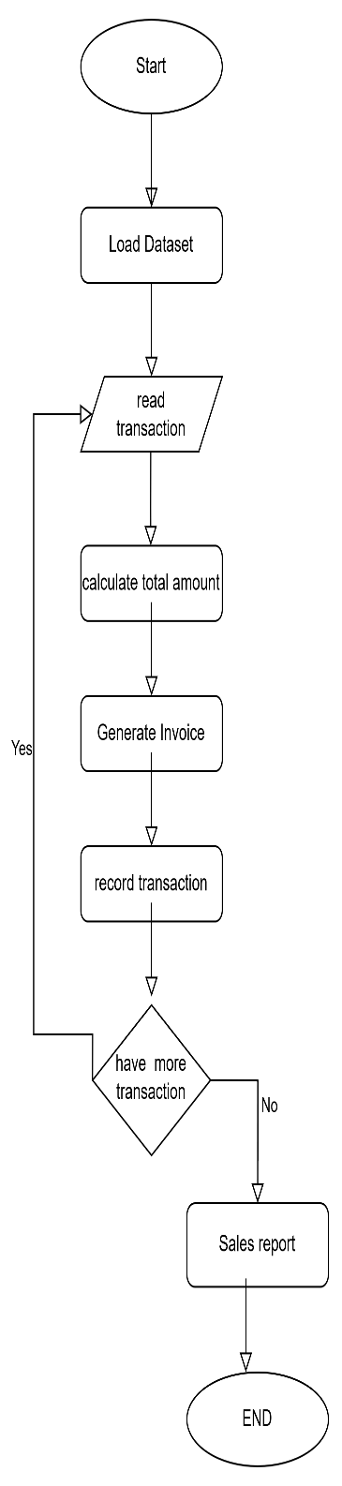

- Pseudocode
Begin

Load Retail Datset
For each transaction:
Read InvoiceNo
Read StockCode
Read Description
Read Quantity
Read UnitPrice

TotalAmount ← Quantity × UnitPrice
Generate Invoice
Record Transaction

End For

Calculate total revenue
Find Top Selling Products
Generate Country-wise Sales Report
Weekly Sales Report

End

- Implementation in Python
View Colab Notebook

